Appendix I – Media Campaign Topics

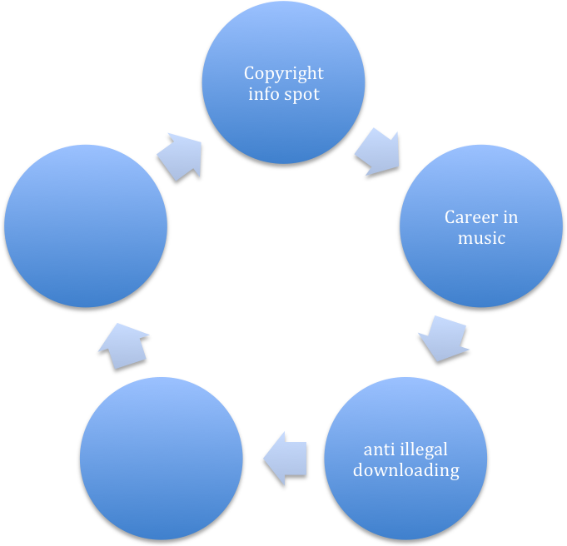

Poster Rough Draft

