Ontario
Alliance for Music: Ontario
MOE Brief:
https://myucdsb-my.sharepoint.com/personal/jim_palmer_ucdsb_on_ca/_layouts/15/WopiFrame.aspx?sourcedoc={E62E41EC-0DA9-40C8-8911-21F3950A39A7}&file=MOE%20Brief%20Final%20May%201%202007.doc&action=default

People for Education Report on the Arts (2013)
http://www.peopleforeducation.ca/wp-content/uploads/2011/12/People-for-Education-report-on-the-arts-in-schools-April-2013.pdf

Cross-Canada Perspective:
Coalition for Music Education A Delicate Balance: Music Education in Canadian Schools (2010)
http://musicmakesus.ca/wp-content/uploads/2010/10/Music_Education_fullreportE2010.pdf
As shown in the table below, three regions of the country have a very large percentage of elementary schools with a specialist music teacher: Quebec, the Atlantic provinces and British Columbia.
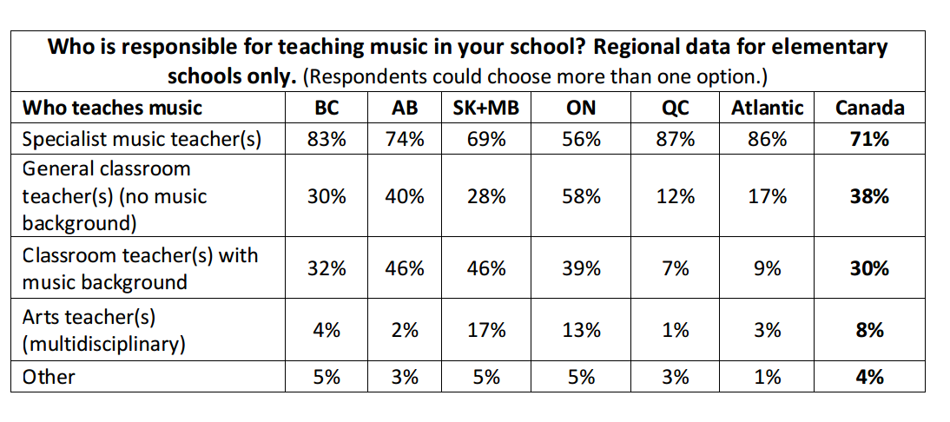
In Quebec, where 87% of elementary schools have music taught by a specialist teacher, there is relatively little reliance on any other type of music teacher. Only 12% of elementary schools in Quebec have music taught by a general classroom teacher with no music background, compared with the Canadian average of 38%.
...
To implement its music education curriculum, Ontario elementary schools rely very strongly on general classroom teachers with no music background.Ontario has the highest proportion of elementary schools with music taught by general classroom teachers and also the lowest proportion of elementary schools with a specialist music teacher:

Newfoundland
Speciality Teaching areas include: "approved subject area" means the area of art, home economics, industrial arts, music or another area that may be approved by the committee;
Qualification in Music:
- Bachelors of Music Education or Music degree/major with B.Ed.
http://www.ed.gov.nl.ca/edu/k12/curriculum/documents/art/arts_found.pdf
http://www.releases.gov.nl.ca/releases/2008/edu/0312n06.htm

Options for Teacher Certification Upgrading-- CERTIFICATE LEVEL V:
Completion of any of the following Memorial University programs will satisfy the requirements for certification at level V:
- B.Ed. (Primary/Elementary)
- B.Ed. (Native and Northern)
- B.Ed. (Intermediate and Secondary) following a 4-year first degree
- B.Mus.Ed. following a 4-year first degree **Music Specialist**

http://www.mun.ca/educ/undergrad/

Nova Scotia
http://nslegislature.ca/legc/bills/57th_1st/3rd_read/b003.htm
http://www.csap.ednet.ns.ca/document/bibliotheque/10%20loi%20education.pdf

New Brunswick
http://www.nbta.ca/services/teacher_certification/cert_bed_clarify.html
Each Canadian province has its own set of requirements for a teacher's certificate. While the registrars for the respective provinces do often collaborate, there are some differences in the required credit hours and/or subject specificity. For example, to teach Elementary Ed in NB you must have a Music credit and a Phys Ed credit. This is not the case in all other provinces , so teachers who have received their BEd in another jurisdiction often are required by the office of Teacher Certification to acquire these credits before they are eligible for a permanent certificate.

