Common Repair Ideas

for Teachers

Seth McNall
OMEA 2015

Trumpet and other piston valve instruments

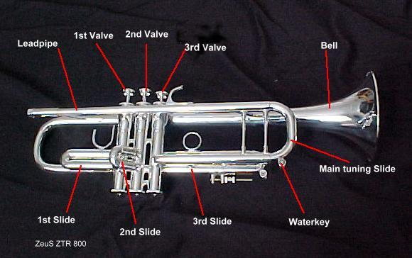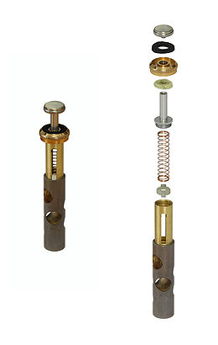

Valve and valve guide orientation
- 1,2,3 (1 is closest to the player)
- turn valve in casing until you hear a click – you can also look into the casing to see which way the guide goes (one wide protrusion and one narrow)
Slides and lubrication
- Use lanolin or slide grease - NOT Vaseline! (it’s petroleum based)
- Move the slides regularly – have students move the slides A BIT every day. A good way to introduce this is having them push the main tuning slide in after every use. When they bring it out they will then need to tune ( a way to introduce that as well)
Yamaha brass instruments
- Slides are very prone to getting seized
- Make sure to keep them well lubricated and move them often
Water key Corks and springs
- There are many different styles – get some and have them on hand (cheap)
- Sizes of cork are dependent on the make and model of the instrument
- Corks are usually friction fit

Felts
- Used to reduce noise between metallic moving parts and align valve ports
- Many different styles and thickness (colour doesn’t determine thickness or style)
- Know where they go (how many do you need in one trumpet?)
- Get some for the instruments you have and keep them close at hand

Lube the valves
- This may sound stupid but do it. “they keep sticking”
- don’t cheap out on valve oil (cheaper is not the same as middle of the road) Hetmans
- oil one valve at a time and test to see if you can play it (this will ensure you have the valve back in the correct way – some valves will “lock in” the wrong way too)

To remove stuck top caps
- first try a tap with a rawhide mallet (gentle not to dent it) this will usually free it up
- I like to use a rubber wrench (adjustable) but stubborn ones send to the shop
- Don’t’ use pliers!!
Specific problems
Trumpets 2nd valve stuck
- Only do this if you feel comfortable!!
- First look for signs of damage on the casing (even a small dent will stop a valve)
- Try pushing the 2nd slide toward the bell (it might have been bent “down” by sitting on the case

Tubas, Euphoniums and Baritones
Mouthpieces
- Keep them secure in the case – a lot of damage comes from a loose m/p in a case
- Kids love to play “let’s shove it in the tuba!”

Stuck valve
- Check to see if the valve stem is bent and rubbing on the top cap (take off the finger button)
- If it is – check to see if the stem is loose - is yes – tighten it
- If it’s tight and rubbing gently take the rawhide mallet and tap it over a bit (hit the stem only)
Rotor Instruments (French horn or Tuba)

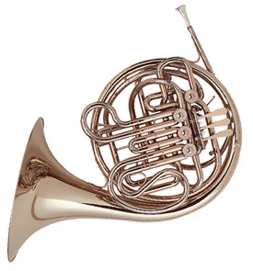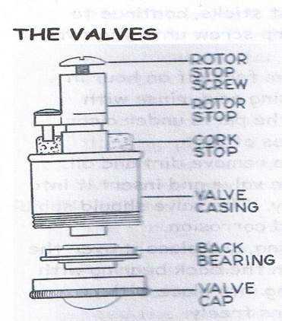
Rotors come in many styles
1 Direct linkage (i.e. no string)
- you must keep the linkages lubed – use a thick oil (10w30 works in a dropper bottle)
2 Stringed
- Buy Yamaha string (yellow) its great stuff!!
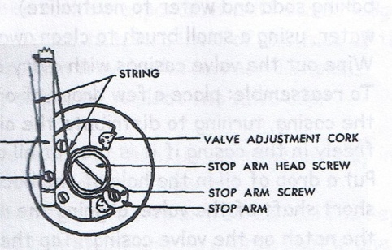
Lubing rotors
- lube bearing points with thicker oil (thick rotor oil)
- lube down the slides (1/2/3) with thinner valve oil)
Check and adjust the lever heights for students who look like they might be struggling to reach
Moving a pinky hook is easy and inexpensive (this will help keep kids playing it)
- it makes them feel special that you altered an instrument for them (customized)
- it makes it way easier to play (more comfortable)
Rotors will seize in a summer. It is not uncommon for all French horns and tubas not to work the first day of school if the rotors haven’t moved all summer
Check the slides are in the correct order!! This happens a lot

Trombone and all slide instruments

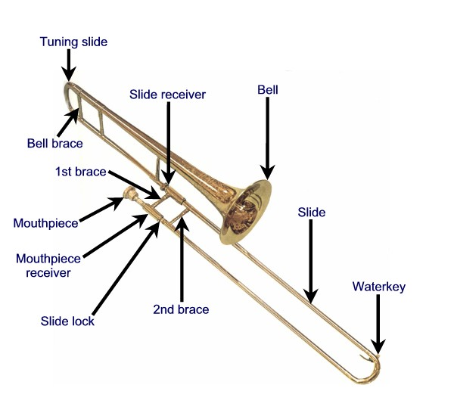
It’s all about the slide- if it gets dented ….
- It doesn’t work
- Kids get frustrated
- If it’s broken then they don’t have to treat it with respect
Make sure the horn is held in place in the case
- If not – fix the case Or buy a new case
Some trombones are dual bore slides
- This means the slide doesn’t fit upside down
- It you have a slide that won’t go on all of a sudden – this could be the problem
Use cream for slide lube if you can
- It’s 3 bucks and lasts a long time OR YAMAHA SLIDE OIL (White and purple bottle)
Show how to properly lube a slide – only need a bit – keep wiping inner slide clean and spray with water

Clarinet
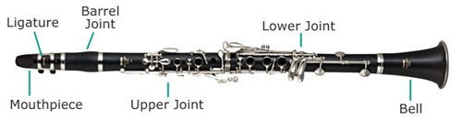
Old broken off cork from tenons don’t go back on – they should be replaced with new cork
Just a bit of cork grease on the tenons
Pad replacement – in emergency only – even then it might not work!
Glue to be used in emergency is hot glue
Lift bridge key (bend it back with smooth jawed pliers if you have any)

Oboes
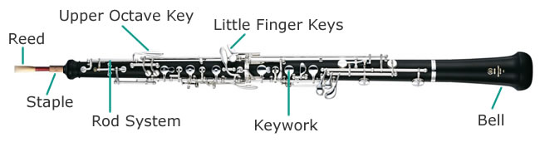
Don’t use pull through swabs – they will get stuck!
Use a feather swab

Flutes
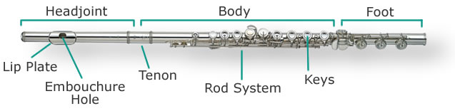
Head joint
- Even a tiny dent will stop a head joint from going in
- Engrave #’s on all 3 parts of the flute
- Head joints don’t swap around
- If a head joint seems stiff STOP PUSHING IT IN - sometimes we can’t get them apart
- Don’t tighten the head crown screw or move it
- Tuning line on swabs
If a flute doesn’t change notes – check the trill key springs
- They are supposed to be sprung shut
- If the spring comes off – they become sprung open most times

Saxes
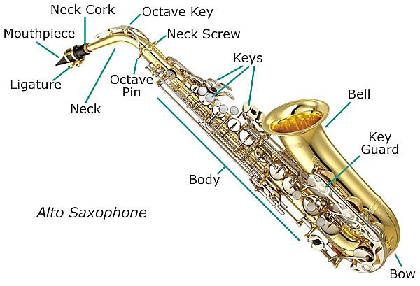
Buy and use end plugs so you don’t bend the octave pin or use SHOVE IT’s
If a pad falls out (and it’s an emergency) glue it back in with hot glue
Neck tension screws (they are really expensive) don’t over tighten them
Old neck corks don’t go back on
Use a large pull through swab for the body
Use a smaller (clarinet size) pull through swab for the neck. (A large one will get stuck on the vent)

General woodwind stuff
If a mouthpiece falls it might be wrecked even if you can’t see any damage
If you have a problem with a woodwind, don’t start tightening screws – NO MATTER WHAT – the regulation screws are set where they are supposed to be. Unless you really know what you are doing you will make things way worse.

General Teacher rules for all instruments

All instruments are to be stored in their case when not in use. (Some exceptions for tubas (BUT make sure branch is turned into the wall so if it falls over it falls into the wall) this will save huge amounts of wear and tear and money later!!
Music books and other items are NEVER to be stored in the case (unless there is proper storage for it in the case (and more things will put strain on the instrument and WILL damage it)
Make sure the case is in good order i.e. The latches and hinges and handles are working and secure (new parts for a case are inexpensive compared to the repair to the instrument when they fall)
Some teachers alternate acid bathing all the brass instruments every two to three years
Year 1 trumpets
Year 2 bones and euphs
Year 3 tubas and fhns
This makes sure that everything gets a good clean and lube every three years. This should not replace cleaning at the end of the school year (Acid removes build up soap doesn’t get) etc
Please leave notes in instrument cases with issues you have
Please don’t send in a totalled instrument and ask us to “ONLY FIX THE WATER KEY”
If you need it back soon – tell the repair shop
If you don’t need it back soon - tell them they are trying to keep everyone happy

Budget
Approx costs for cleaning
- Trumpet 30.00
- Bone 30.00
- Euph 50
- Tuba and Fhn about 70-100.00
- Clarinet tenon corks 10-20.00
- Sax neck corks -10-15

Overhauls vs. new purchases - if the instrument is a good quality instrument, overhauling is usually cheaper and just as good as buying a new one!
Tools and materials needed
A REALLY good mouthpiece puller (get a bobcat) about 100.00
Rawhide mallet (not too big)
Pad slick
Good screwdriver set (Canadian Tire ones are great!) Get Phillips (star) and slot
Spring hook (or small crochet needle)
Cut off drum stick – to reach caps where a hammer can’t get to
Water key corks for your instruments
Small number of assorted clarinet pads (like 2 or 3)
Extra ligatures for instruments
Extra mouthpieces for woodwinds
Yamaha French horn string
Good sharp scissors
Towel for work bench or your desk (keeps it clean and no scratches on the horn)
Hot glue and gun

